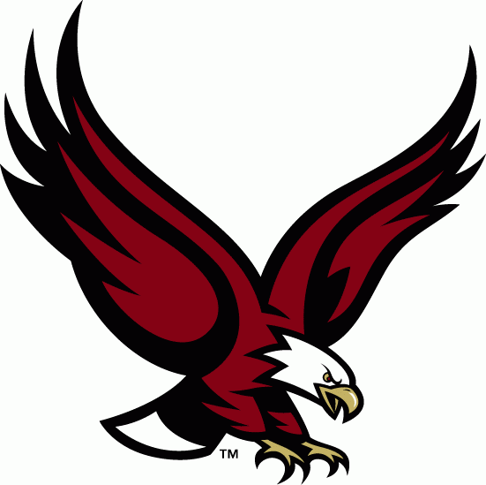

* Writing is Everywhere at Golden Hill.
* New “Eagle Feather Initiative” to Help Encourage S.O.A.R. Behavior…
* If you Haven’t Heard, Golden Hill is a LEVEL 1 School!!!!
* Winter is Here, Dress Warm and Please Drive Carefully.
* Read, Every Day, Reading is so Important – READ!

We also had a winning writer…Alexandra Fraser… in the “How to Keep a Healthy Smile” contest!

Another student, Eleanora Connolly, met the Mayor and City Council when she shared a letter about a subject close to her.

Students at Golden Hill have been writing about Dr. Martin Luther King, and “small moments,” (such as a favorite time or favorite place).

Students write every day, and share their writing with classmates as well as displaying it for all to see.

We have so many great writers!

**Practice math facts with your child for about 10 minutes EVERY day. It can make a difference if you do it every day!**

**Keep in touch with your child’s teacher – working together we can make a big difference.**

**Some important Reminders:**

**To help limit learning disruption, no electronic devices should be brought to school.**

**If there is a change in dismissal for your child, it must be communicated by note or email – as soon as you know of the change.**

**Please notify the office of any changes in address or phone contacts, as soon as you know.**

**Pancake Breakfast was a great success! Thank you to all the staff that helped…and all those who attended!!**

**Great Book Fair!! Thank you Mrs. DiBurro and Mrs. Maneen, and all other volunteers.**

**“Bosco,” a professional dance artist, visited the school to work with students in grades 3 and 4, they had a fun time! Thank you Mrs. Sprague for setting this up!**

**Our first Title 1 parent night was a great success. Mrs. Ewell and Mr. Rosso lead the team to help make “Math Night” a success. Thank you to Mrs. Starble, Mrs. Mellor, Mrs. Onofaro, Mrs. Rodriguez, and Mrs. Mendoza! And thank you to all who attended!**

**We are looking for more School Council Members, contact Mr. Michitson for details**

***Three Cheers for all the hard work our English Language Learner students and teachers have done. The testing for our English Language Learner students is wrapping up and they have worked hard to show their best learning!***

## Student Writing -

## 

## 

## 

**WHERE EAGLES SOAR,**

**SCHOOL NEWS LETTER, 2016 Winter ISSUE#2**

GOLDEN HILL

WHERE EAGLES SOAR!