 

CONGRATULATIONS TO OUR GRADE 4 CHORUS. MR. DAVIS DID A GREAT JOB, AND KUDOS TO THE WHOLE GRADE 4 TEAM FOR SUPPORTING OUR PERFORMERS!! ***A school with strong arts and wellness instruction, supports all*** **learning.**

THE “PAX” SCHOOL WIDE BEHAVIOR PROGRAM KEEPS ON GOING!!

The grade 2 team used their bulletin boards to share their spirit for a PAX school. One idea about PAX is always looking for clearly defined PAX behavior. Kids help define that behavior in their class “Vision.” One thing we learned form PAX was to always…always look for kids doing what is expected and notice it! Different research on noticing “good” behavior and noticing inappropriate behavior suggest ratios of 4:1, 5:1, or 6:1. The general idea is – WHEN KIDS ARE DOIING THE RIGHT THING WE TRY TO QUCKILY AND SPECIFICLLY NAME IT AND NOTICE IT!

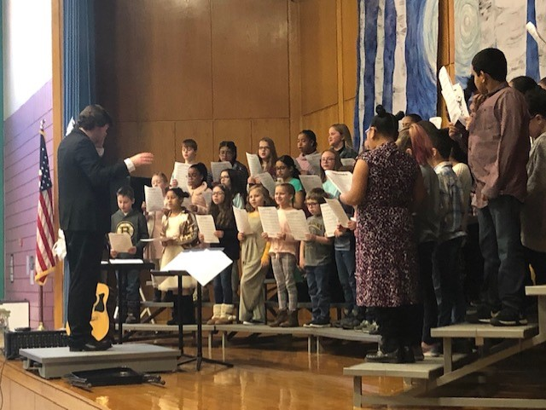

***Thoughts From The “Chalkboard”***

**Vacation:** February 17th – 21. **Arrival**: If you arrive at school at 9am or after, you must sign-in your child. **Contact Information**: All contact information must be current and accurate. If phone numbers, emails, or addresses change the school must be notified.

***What is a Massachusetts learning standard?***

*Well, here’s an example for grade 3 math:*

*“Explain equivalence of fractions in special cases, and compare fractions by reasoning about their size.*

* 1. *Understand two fractions as equivalent (equal) if they are the same size, or the same point on a number line.”*

For students to meet this standard they need to work with a lot of different fractions, represented by numbers or visually. And, they need to be able to explain their thinking.

*Here are English Language Arts standards, for grade 1:*

Reading - *“Describe characters, settings, and major events in a story, using key details.”*

Speaking and Listening - *“Follow agreed-upon rules for discussions (e.g., listening to others with care, speaking one at a time about the topics and texts under discussion)*.

For students to meet these standards, they need to read, and be read to. The texts (stories, books) that read should have variety of subject and culture, and be of good quality. Students should have structured discussions (*a lot of them*) about the texts they read and about other topics (science, math). Consistent guided practice is needed.