What is Bullying
Definition:
Bullying is when an individual or a group of people with more power, repeatedly and intentionally cause hurt or harm to another person or group of people who feel helpless to respond. Bullying can continue over time, is often hidden from adults, and will probably continue if no action is taken.
In order to be considered bullying, the behavior must be aggressive and include:
- An Imbalance of Power: Kids who bully use their power—such as physical strength, access to embarrassing information, or popularity—to control or harm others. Power imbalances can change over time and in different situations, even if they involve the same people.
- Repetition: Bullying behaviors happen more than once or have the potential to happen more than once

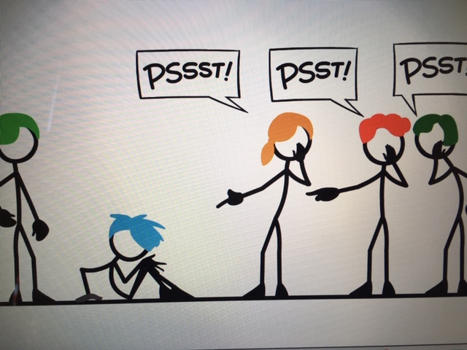

What bullying is not
- Social conflict (student not getting along) is not bullying, although we do respond. Most typical day to day social conflict is addressed at the school successfully.
- single episodes of social rejection or dislike is not bullying
- single episode acts of nastiness or spite is not bullying
- random acts of aggression or intimidation is not bullying
- mutual arguments, disagreements or fights is not bullying
These actions can cause great distress. However, they do not fit the definition of bullying, and they're not examples of bullying unless someone is deliberately and repeatedly doing them.
Take Steps to Stop Bullying
- Start early. Parent/child talks are essential. Teach kids to respect others before they start school and continue to talk about this topic on an ongoing basis. Even small acts of teasing should be stopped in their tracks. Don’t fail to correct this kind of behavior due to a child’s young age. This is exactly when to stop it.
- Teach your children how to be assertive. Encourage your children to express their feelings clearly, say no when they feel uncomfortable or pressured, stand up for themselves without fighting and walk away in dangerous situations.
- Listen and support children who speak up. Telling an adult about bullying is not easy for children. If a child comes to you seeking assistance with bullying, spend time listening to them and provide affirmation and support before taking actions.
- Tell your children to take action when they see bullying behavior. Tell them to speak out against the bully and inform a teacher if the behavior doesn’t stop. Bullying continues only when we allow it to.
- Reach out to the school if you suspect your child is being bullied.

For more information – check out the Golden Hill website!
Or
you can contact the school at 978-374-5794

