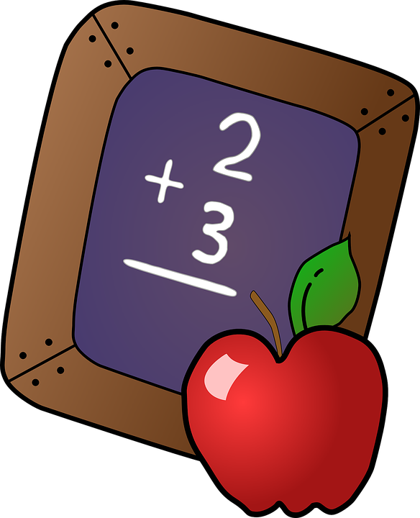

11/10/2022

Dear Golden Hill Families,

Math is an important skill, and knowing math facts is essential in building a strong math foundation. We would like to have a math contest this year that focuses on math facts. This will target grades 2-4. Your help is greatly appreciated in supporting us with this project.

Here are the expectations:

- Grade 2 - Addition and subtraction to 20
- Grade 3 - Addition and subtraction to 20, Multiplication to 12
- Grade 4 - Addition and subtraction to 20, Multiplication to 12, Division to 12

Here are some resources for practicing math facts.

- Try virtual flashcards at https://www.factmonster.com/math/flashcards
- Print some math fact papers at https://www.worksheetworks.com/math/basic-operations.html
- More virtual flashcards at
https://toytheater.com/math-flash-cards/

Please have your child practice math facts on a regular basis. Long car rides are a great time to practice! We will send monthly reminders. We will hold a contest in April similar to a spelling bee but with math facts. What fun!

We will offer more details in the following months.

Thank you for your support!

Lauren Sanguedolce, Math Interventionist
Ellen Fahy, Math Interventionist

