Reading Rally at Golden Hill School – PTO Brings Children’s author – and Super Bowl Champ - to Kick-Off “Read Across America” and the Golden Hill Read -A –Thon.

The Golden Hill PTO brought Malcolm Mitchell, “Literacy Crusader,” to Golden Hill School to share some of his experiences with the challenges of reading and how important reading is.

Malcolm is a retired NFL player who was a receiver for the New England Patriots. He caught six passes for 70 yards (5 catches in the 4th quarter) in the Super Bowl LI. This was the famous overtime win against Atlanta.

Malcolm’s first book was published in 2016, “The Magician’s Hat,” and he read his new book with the entire student body of Golden Hill school – right after a magic demonstration! Malcolm shared that he loved the NFL, but becoming an author, and Literacy Crusader, is what he is most proud about. It is especially satisfying because reading was not easy for Malcom and letting kids know that they can – and should - become readers is important to Malcolm. Malcolm has visited over 300,000 students and his foundation has put books in the hands of 65,000 kids. His energy and enthusiasm were contagious! Malcolm said, “Your kids are great, you have a great school.” Yes we do!

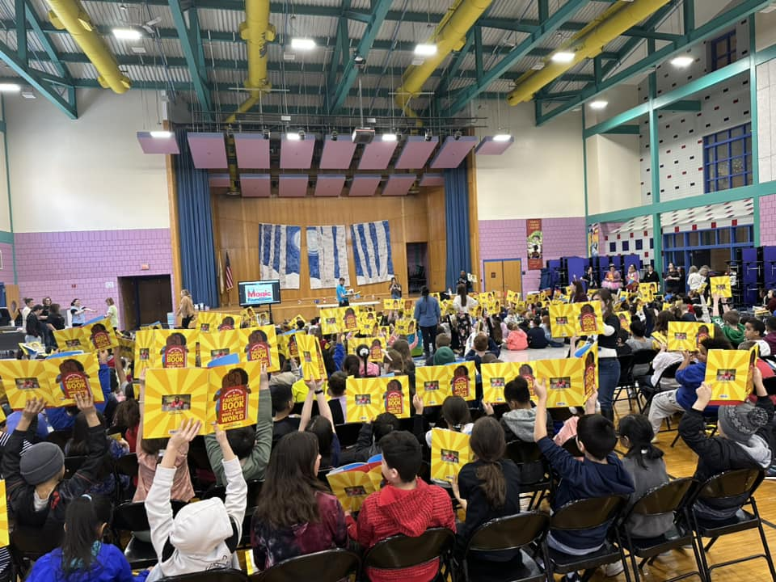
Students hold up their books, Malcolm’s new one – “My Very Favorite Book in the Whole Wide World.”
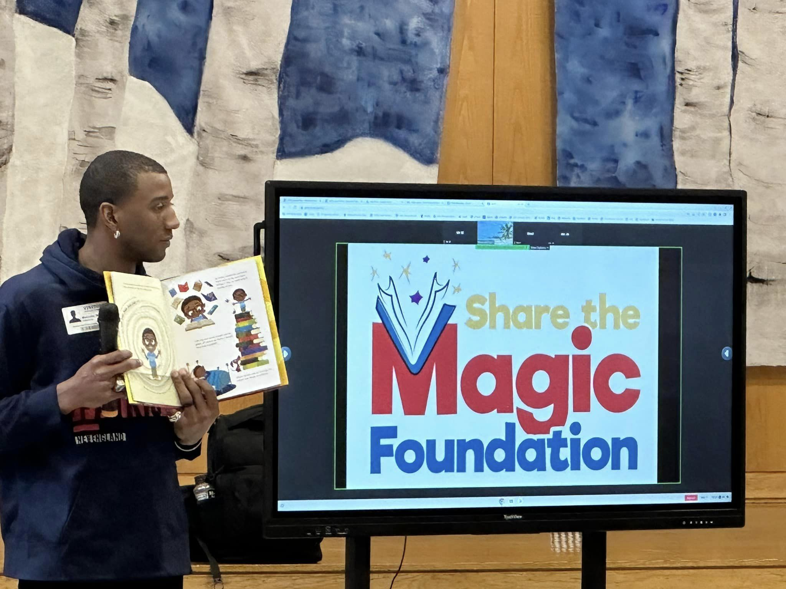
Malcolm reads to the 470 students of Gold Hill
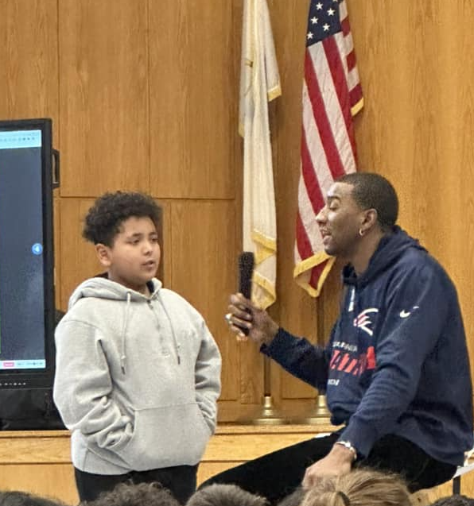

Malcolm answers a question from grade 4 student, Angel Rendon.

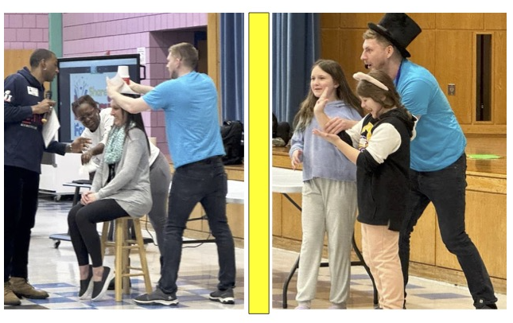
Meghan Lawner (grade 1 teacher), Ashlinn Bradley, and Charlotte St. Hillaire act as Magician Assistants during the Reading Rally

Keep in touch with Golden Hill through Facebook and our website –
FB: https://www.facebook.com/GoldenHillSchool
Web Site: https://goldenhill.haverhill-ps.org/

Lindsay Bradley- PTO President, Principal Bruce Michitson, Malcom Mitchell, and John Logan (Magician).

