Haverhill Public Schools
Golden Hill Elementary
School Improvement Plan
2023-2024

Executive Summary
This School Improvement Plan includes information on the district’s initiatives and core values. It also includes evidence of Golden Hill’s progress when examining IREADY data, DESE profiles, information on the current student population, information from our strategic plan developed in 2019 and current progress, as well as PAX data. This year’s action steps for Golden Hill’s school wide goals will continue to align with the district’s mission for 2021-2022 school year.
District Mission and Core Values
In partnership with our community, the Haverhill Public Schools is committed to excellence in education and will meet and exceed academic and developmental goals of success for all students. We are dedicated to ensuring each learner meets or exceeds rigorous academic standards to become a citizen with integrity, skills, and the resources to succeed in the global community.
  - High Expectations
  - Equity
  - Respect
  - Collaboration
  - Growth Mindset
Golden Hill’s Mission, Vision, Core Values
- Mission: The fundamental purpose of the Golden Hill Elementary School is ensuring high levels of learning for all students. Therefore, we will do whatever it takes to bring all students to their full potential.
- Vision: Golden Hill Elementary School will be a place where all students, staff, and families feel safe, welcome, and valued. Collaboration will be of utmost importance and ever-changing. The Golden Hill community will consistently reflect, learn, and act to promote and support the growth of all.
- Core Values:
- Commit to each task or each interaction with honesty, integrity, and transparency.

- This is important when collaborating, communicating, and in our day-to-day interactions. It creates a culture of risk taking and an environment that feels safe. We may make mistakes in the process, but if we commit to doing what we think is right, then we will persevere in creating student successes.

- Have empathy with others.

- Have acceptance and understanding of others because you never know what the other person is going through
- Listen to understand, not to respond
- Build strong and positive relationships
- Presume good intentions
- Celebrate differences in all people and in all ideas

- All students can and will learn.

- We must have a commitment to do what is in the best interest of students and create a school community that believes that all of our students are all of our students. As Rita Dunn once said (an expert on learning and teaching styles), “If the child is not learning the way you are teaching, then you must teach in the way the child learns.”

- Consider the whole child - build strong hearts, strong character, and strong minds.

- All students need academic and social emotional learning support
Who are OUR Students at Golden Hill Elementary School?
According to the DESE School and District Profiles (2022-2023), as well as the Haverhill Public Schools information system (school brains), Golden Hill has an enrollment of 483 students in grades kindergarten to grade 4. Of this student population, about 47% are Caucasian and about 45% are Hispanic. About 21% of students enrolled are English Language Learners. It is also important to note that about 72% of our student enrollment is “high needs” and about 63% of our enrollment is students that are economically- disadvantaged. Additional information worth noting is that 51% of our students showed substantial progress toward state-wide assessment targets. This is improvement from previous years but also shows the need for further improvement.

Enrollment rates of Student Race/Ethnicity (enrollment in percent)
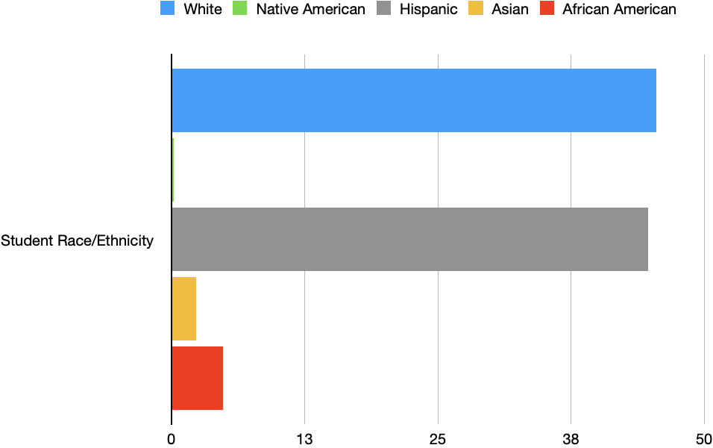
 | Student Race/Ethnicity
African American | 4
Asian | 2
Hispanic | 45
Native American | 0
White | 47
Hawaiian, Pacific Islander | 0
Multi-Race, Non-Hispanic | 2

Enrollment Rates for Selected Populations (enrollment in percent)
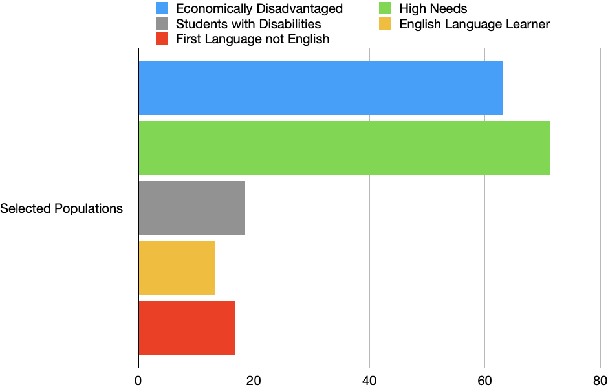

 | Selected Populations
First Language not English | 17
English Language Learner | 21
Students with Disabilities | 13
High Needs | 72
Economically Disadvantaged | 63

https://profiles.doe.mass.edu/mcas/achievement_level.aspx?linkid=32&orgcode=01280026&orgtypecode=6&

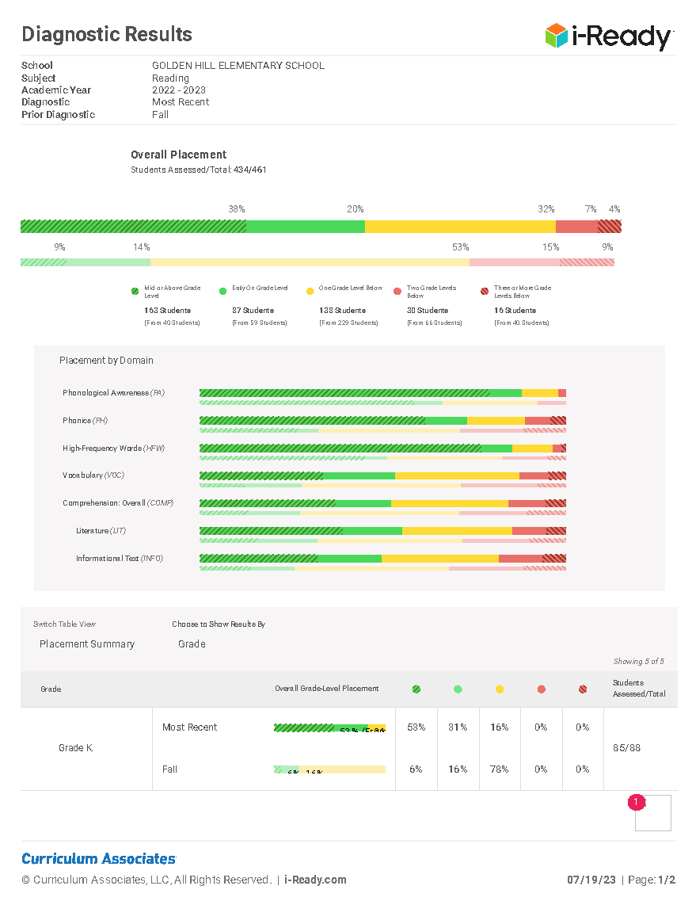

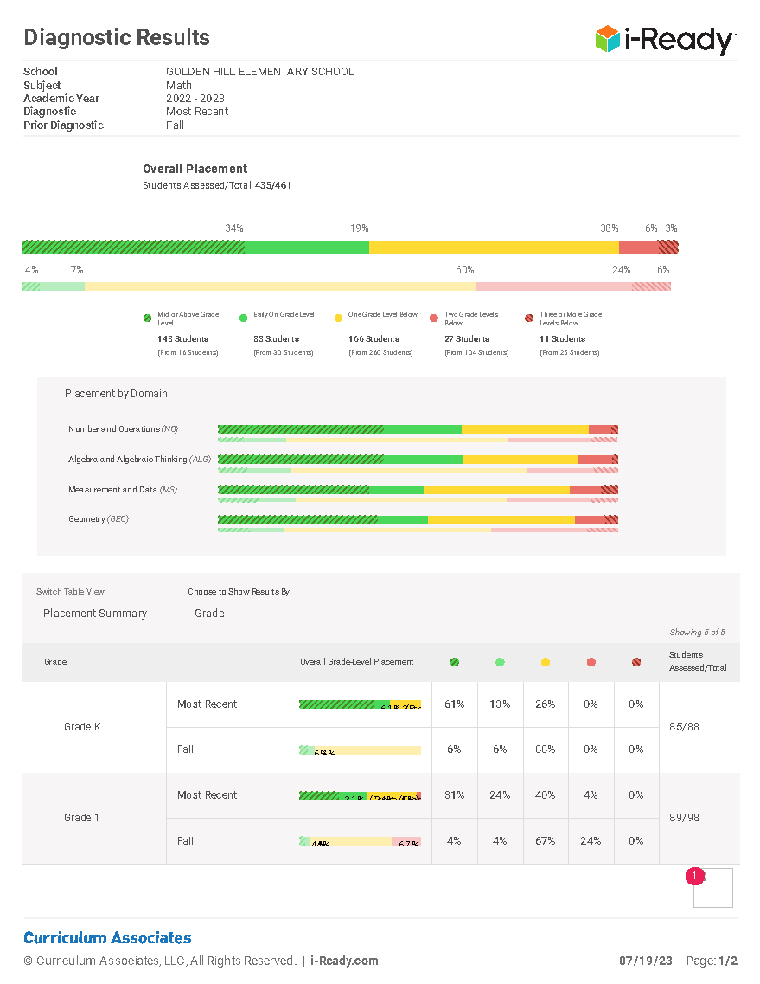

Strategic Objective #1 - Tiered System of Instruction
What Does This Mean?
The school acknowledges an unacceptably high percentage of students are recognized as
“high risk” for not meeting DESE-determined educational outcomes. Of that group, a significantly high percentage of these students are recognized as “high needs,” and students who are historically underserved.
Next Steps:
- Golden Hill will develop a common understanding of effective intentional instructional practice and Multi-Tiered System of Support, including a system of intentional core instructional practice.
- Work will be supported, led, and monitored by a robust system of school-based and district leadership.
- A social emotional curriculum and common set of behavioral expectations will build a safe and supportive school.
- Professional development and structured collaboration will align with school needs and be directly practiced in instruction.
- Data will guide progress monitoring and instructional decisions.
Theory of Action / Benchmarks:
- Teachers will demonstrate a common and systematic understanding of Tier I instructional practices and expectations for teaching and learning to meet the needs of all students, including historically-marginalized students using an ILT and/or district developed rubric of Tier I instructional practices and expectations.
  - Educators will reflect on instructional practices and develop their professional learning on standards-aligned practices through identified and observed practice behaviors through the use of a walkthrough rubric (observations completed by ILT and district members, with the opportunity for classroom teachers to participate in observations), baseline collected at the end of September. There will be 3 follow-up data collections; November, first two weeks of January, and March.
  - Educators will have Tier 1 intervention scheduled into their instructional time, at the start of the year (September) and will have professional development as well as opportunities to observe Tier 1 interventions as part of identified practices.
  - Golden Hill members will utilize Iready Pathways strategically and with fidelity
  - SST members will develop specific intervention plans for students
  - Coaches will support teachers with developing tiered instruction plans
  - Interventionist will use school wide data to develop individualized plans for specific students
  - Our school wide PAX program will be implemented with fidelity for all students
  - School adjustment counselors will support teachers with SEL curriculum that supports our PAX program
  - PAL program will support specific students by developing individualized plans

Strategic Objective #2 – Core Data Foundation
What Does This Mean?
The school acknowledges it does not have a robust (organized, resourced) system of on-going data collection and analysis that allows teachers and students to identify and target individual and group needs (academic and social / emotional) and plan for instruction in every classroom.
Theory of Action / Benchmarks
- Teachers will demonstrate professional collaboration via shared data inquiry at the grade team level, leading to documented instructional change; this will be observed by ILT using a developed rubric on professional practice around shared data.
  - Educators will have data, or evidence of student learning (student work for example), that is directly related to DESE Frameworks, and the data will anchor the conversations during established meeting times, starting in September, and continuing throughout the year (3 additional data collection days). Measured by observation/facilitation by district/school support, and by artifacts (agenda, notes) – starting in September, and continuing throughout the school year.
  - Educators will evidence direct actions, based on data analysis, measured through data collection cycle (see 1a above).
  - The instructional leadership team will be established and supported in building its capacity and expertise.
  - Data collection, analysis, and transition to classroom use will be systematized with procedures for inquiry cycles and progress monitoring created.
  - Collaboration and professional development will be based on data and evidence for decision making.
  - Interventions for individuals and groups of students will be planned keeping this data at the forefront.
  - School wide initiatives, CPT, and SST will center around data discussions, planning, and conversations to improve student growth.
  - Data Days (3 times per year) will focus on examining student data and strategic planning intervention groups of individual and groups of students.

Strategic Objective #3 – Social Emotional Learning / School Wide Behavior Program
What does this mean / What is PAX?
There are many research-based programs that support social emotional learning practices. PAX Good Behavior Games is just one of those programs. Dr. Dennis Embry, proponent of PAX Good Behavior Games, has participated in years of research on this program. His research has shown that PAX helps children improve their self-regulation and self-management skills, prevents life-time mental health problems, prevents bullying, and promotes school success.
Brief Summary of the Current Status and History of the School Wide Behavior Program-PAX
When considering the school’s population of students, a team at Golden Hill collaborated to determine the best steps for students. In a well-developed Turn Around Plan (June, 2019), in conjunction with members from the Department of Secondary and Elementary Education, it was decided that Golden Hill was in need of a “consistent, school-wide, social emotional learning curriculum and behavior plan that is understood, accepted, acknowledged and implemented with fidelity by all staff, students, and families” (p. 3). From this need, the school team members developed a vision for a school wide behavior program. This vision called for the support of student emotional needs, to include social emotional learning for everyone. The program would address equity issues by addressing the learning needs of all students in this area by aligning the behavior plan to the school’s curriculum.
The team determined that the PAX program would support the vision and needs of the school. This is because PAX teaches children to work together for a common goal and to focus on a positive future, creating and instilling life-long strategies for children. PAX teaches core cognitive, emotional, and behavioral skills required for productive and happy lives. It also creates common language and teaches the best support strategies for teachers and families (Dr. Embry, The PAX Good Behavior Game). Therefore, we began the implementation of this school wide behavior program in the 2019 school year. Again, this is a research-based program to support not only our marginalized populations, but all students. Since the implementation in 2019, the program has been essential to promoting engagement, to decreasing office referrals, and to building positive character traits and relationships for all.
Current Office Referral Data
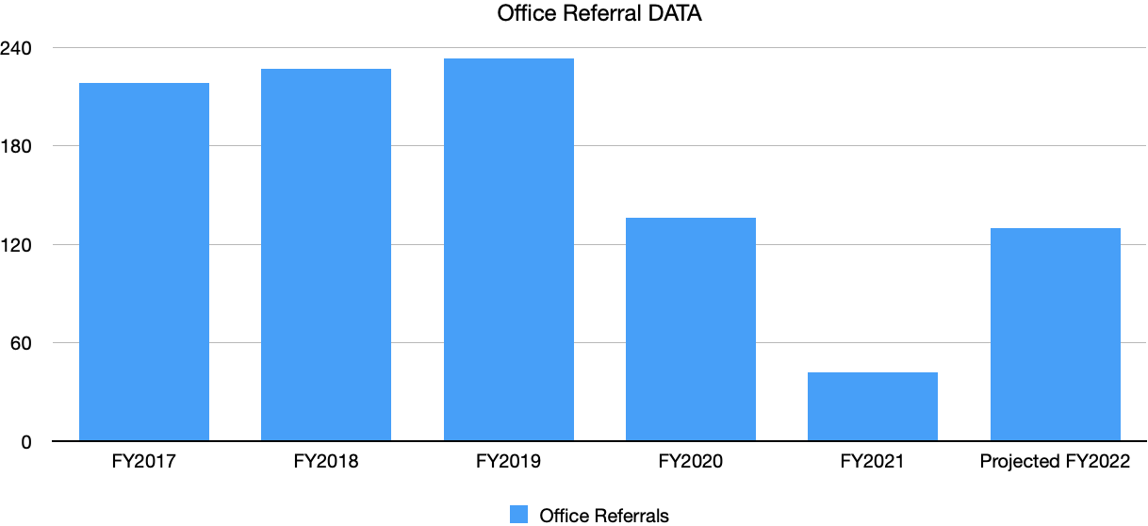
 | Office Referrals
FY2017 | 218
FY2018 | 227
FY2019 | 233
FY2020 | 136
FY2021 | 42
Projected FY2022 | 130 was 135

When analyzing the current “overall” office referral data prior to PAX (FY2017, FY2018, and FY2019), there were over 220 office referrals each year from August to March. The data is being represented only through March in order to be consistent, as we were not in school in FY2020 for the months of March-June due to the pandemic. In the program’s first year of implementation, FY2020, there were 136 office referrals, this was a decrease of 84 office referrals. In FY2021, there were 42 office referrals, but it is difficult to truly ascertain the true progress of the program this past year because of the lack of consistency with in person learning.
Next Steps:
We should continue with the PAX program, refining and expanding the program through further character development and coping strategies. This “next step” training, provided by the PAX institute, took place in August 2021. With this “next step” training and with consistent implementation and consideration of the next action steps, it is fair to determine that the office referral rate would remain at a similar pre-pandemic, at the program’s initial implementation, as demonstrated in the above data display.
Theory of Action / Benchmarks:
If we continue to expand our knowledge of social emotional learning and if we continue to implement, with fidelity, our widely accepted and understood school wide social emotional behavior plan then we will create a caring and inclusive environment, which will in turn, support all students in reaching their full potential.
- Students will build problem solving skills, conflict resolution, enhanced empathy, and a positive mind set, as evident from data collected three times per year utilizing the PAX classroom scan.
- Students will increase classroom engagement as evident by a decrease in office referrals (analyzed monthly).
- Teachers/leaders/staff will examine and develop their own practices on how to address the social emotional needs of all students, as evident by teacher surveys and teacher collaboration in leadership meetings (surveys to be “sent out” and analyzed three times per year).
- Parent surveys will be “sent out” and analyzed twice per year to examine student mindsets, desires to attend school, and social-emotional well-being.
- Secondary evidence of achieving equity of achievement for all students (addressing the social emotional needs for all students) will be an increase in achievement scores (school-based assessments and state wide testing).
As mentioned, this school wide behavior plan addresses equity of achievement issues by helping the school community to promote understanding of all students, reflect upon the differences in individuals through relationship building, and help all students reach their full potential. Relationship building is at the core of this school wide behavior plan, which will address school wide practices that may impact equity and bias. The plan will help all students and staff understand the assets in individual differences and diversity and will teach acceptance and kindness. This will close achievement gaps and create a more inclusive school community.

It will be important to demonstrate the successes and endurance of the PAX program with not only at-risk students but all students in order to continue receiving this revenue. This will be done through clear and systematic data collections with the following outcomes.
  - An increase in student problem solving, conflict resolution, enhanced empathy, and a positive mindset (data collected 3 times per year using the PAX classroom scan)
  - An increase in student classroom engagement with a decrease in office referrals (data analyzed monthly)
  - An increase in teacher/staff/leader examination of their practices for how to address the social emotional needs of all students (data collected 3 times per year through surveys)
  - An increase in student desire to attend school, and the student overall social emotional well-being from the parent and student point of view (parent survey)
  - An increase in achievement scores for all students (secondary evidence of achieving equity of achievement for all students, as evident in school based and state wide testing)
The ultimate long-term goal of PAX will be that it is embedded in all aspects of the school and learning environment for all students, for all staff members, and for all families. Golden Hill members will increase their sense of connectedness and will feel a sense of community as PAX is consistently implemented and monitored. One can conclude that the staff are invested in the program from the number of staff members (all teachers volunteered and approximately half of the paraprofessionals in the building volunteered) that volunteered to attend the “next steps” training at a time that was not in their contractual hours.
Most importantly, in order to continue to have such successes with PAX, we will need to keep PAX methods in the forefront by consistently meeting with staff members about strategies, steadily sharing data, regularly celebrating successes, and always moving forward with PAX “next steps” while avoiding stagnancy.
Strategic Objective #4 – Family / Community Engagement

What Does This Mean
Golden Hill acknowledges that there is a small number of parents/guardians and/or other family members reporting an understanding of the school's improvement efforts, the targets the school is striving for, and their role in contributing to reaching these goals. Prior to 2018, on average, 150 families attended family engagement events that were linked to learning. From 2018-2020, this number decreased to approximately 50-100 families. At the start of 2021, there were 150 families in attendance at one Golden Hill Family engagement event.
There is also a small percentage of teachers, students, and families agreeing that the school offers regular opportunities to publicly celebrate student/school success, recognize achievement and reinforce high expectations. In 2019, a family engagement survey developed by our leadership team was completed by our school families, and 85% of families communicated their desire for a stronger connection to the school through more inclusive practices, which included a stronger connection of students to teachers.

Next Steps
- Begin with the premise that parents do care about the school community and find opportunities to include families with a variety of backgrounds.
- Provide opportunities to reach families in a variety of formats (email, phone calls, application programs, social media).
- Events should have a focus that is relational, builds capacity of families and staff, and is linked to learning.
Theory of Action / Benchmarks:
If family and community engagement is a shared responsibility that is viewed a valuable, and if those sharing the responsibility are committed to consulting and engaging families in school decisions, and if we, as community partners, are willing to implement a varied approach to engaging families from diverse backgrounds, then family and community engagement will be a meaningful contributor to increase student performance, greater social emotional wellness, and an improved culture.
- We will provide opportunities for community volunteers within the school setting, inviting families to observe and support classroom learning opportunities.
- Decision making will be shared, with opportunities for parents to discuss, collaborate, and understand the school wide data and then the development of action plans made to make school wide improvements.
- Family/community nights will include opportunities for families to understand the curriculum, to include modeling of learning support strategies.
- Communication between the school and community will be multifaceted, to include positive phone calls home, use of a school wide application, emails, in person discussions, and opportunities to connect with families in a meaningful way.

