Haverhill Public Schools

April Vacation Academy 2024
In Partnership with:
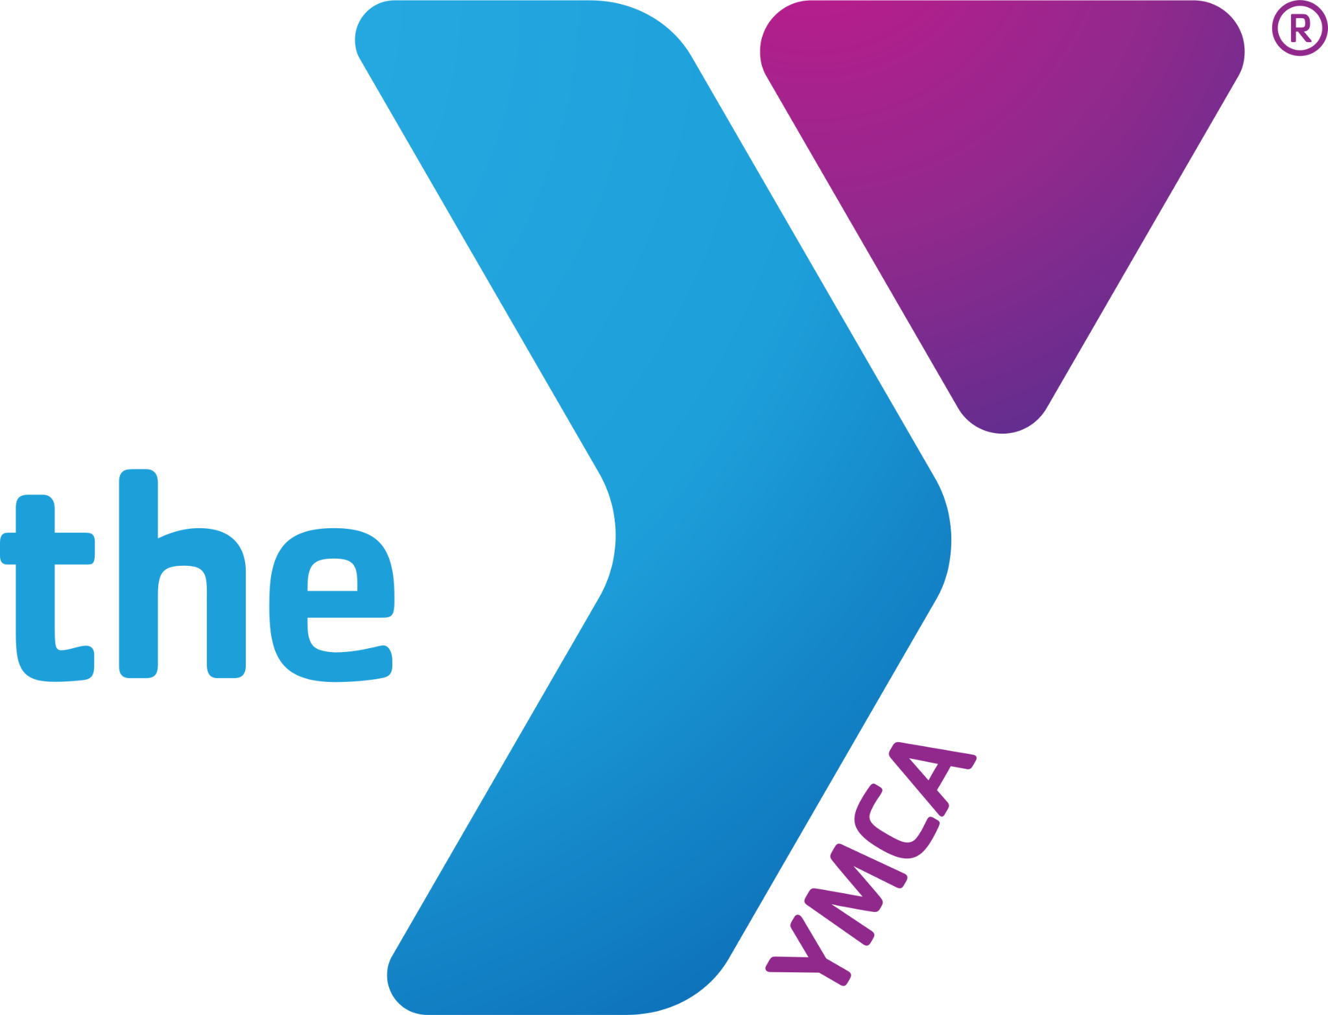
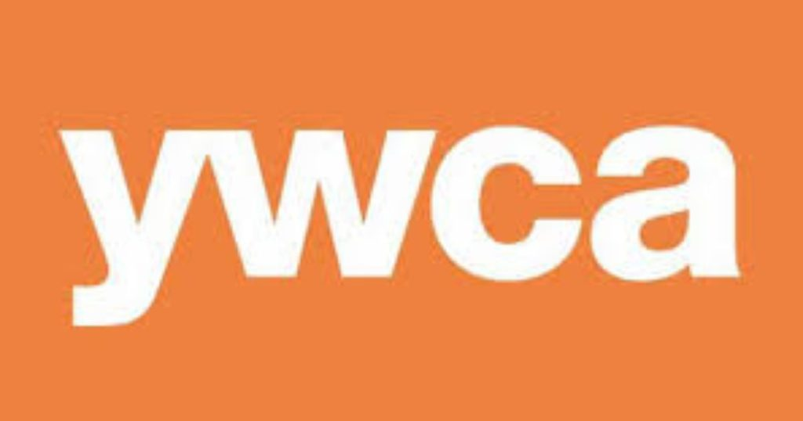

What is it? Academic lessons and recreational activities during April vacation to
keep students engaged in learning and to provide working families with an option of high quality childcare at no cost.

Where? Boys & Girls Club YMCA YWCA
55 Emerson Street 81 Winter Street & 107 Winter Street
Lilly Ruiz Pentucket Lake School Amy Desimone
frontdesk@haverhillbgc.org Cathy Wolf adesimone@ywcamema.org
(978) 374-6171 ext. 100 wolfc@northshoreymca.org (978) 374-6121 (978) 374-0506

When? Tuesday, April 16 - Friday, April 19
Daily Hours: 8:30 am - 5:30 pm (Note: YMCA closes at 6:00 pm)
Academics: 8:30 am - 12:30 pm
Lunch: 12:30 pm - 1:00 pm
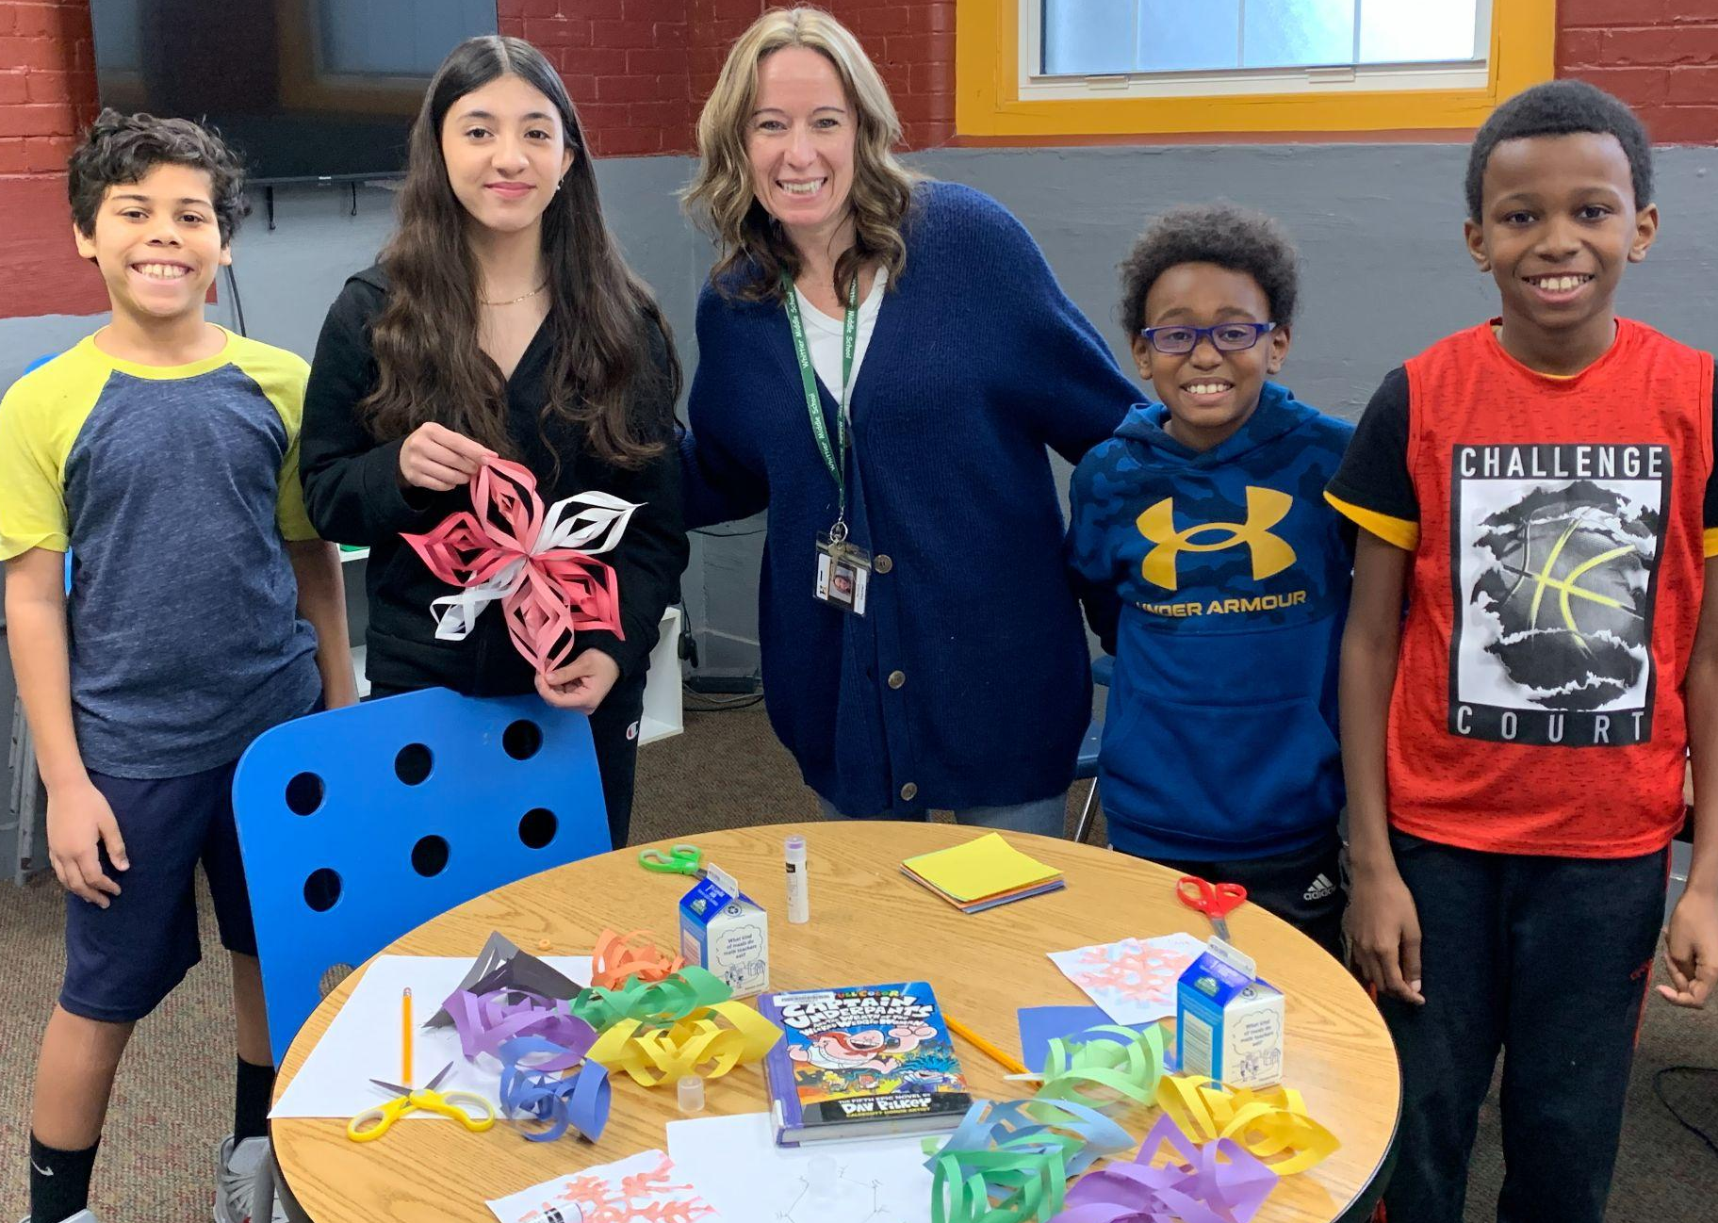
Recreation: 1:00 pm - 5:30 pm

Who Can Attend? HPS Students in Grades K - 8

How Do I register my child?
Call the program location of your choice (see above)!

Note: Students must be enrolled in a Haverhill public school but do not need to be members of the organization to attend!

